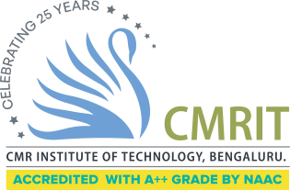
CMR INSTITUTE OF TECHNOLOGY
ACADEMIC YEAR 2025-2026
Flipped Classroom REPORT
DEPARTMENT OF INFORMATION SCIENCE AND ENGINEERING

Subject code | BIS601 | Course Name | Full Stack Development-MERN
Semester / Section | 6C | Prepared By | Vijayasanthi m
Curriculum Gap Identified: | NA

Summary of Flipped Classes conducted:
Sl No. | Topic | Date | Flipped class / Video Session(Choose from dropdown) | Total number of students
1 | DOM | 27/02/2026 | Flipping the teacher
2 | Express JS | 25/03/2026 | Group Based
3 | MongoDB | 20/04/2026 | Discussion Oriented

Detailed Report
1 | Topic: React Components: Issue Tracker, React Classes, | Date: | Flipping the teacher | No. of students

Conduction of Flipped Classroom

Evaluation :

Outcome:

Detailed Report
2. | Topic: | Date | Flipping the teacher | No. of students:

Detailed Report
2. | Topic: | Date | Flipping the teacher | No. of students:

